**Blackjack Odds Calculator Report**

The Blackjack Odds Calculator is a C++ program designed to provide users with insights into the probabilities associated with a game of blackjack. This report aims to elucidate the purpose of the code, its underlying functions, and pertinent details for better understanding.

**Purpose of the Code**

The primary objective of the Blackjack Odds Calculator is to empower players with a strategic advantage during blackjack games. By simulating potential outcomes based on the initial hands of the player and dealer, the calculator offers valuable insights into the probabilities of winning or busting. This tool is particularly beneficial for players looking to enhance their decision-making process and overall gaming strategy.

**Code Overview**

*Initialization and Deck Setup*

The `BlackjackCalculator` class begins by initializing a standard deck, consisting of numbered cards (2-10) and face cards (10, 10, 10, 10). This initialization is crucial for subsequent probability calculations.

*Probability Calculations*

`calculateCardProbability(int cardValue)`: This function determines the probability of drawing a specific card from the remaining deck. It utilizes the `std::count` function from the `<algorithm>` library to count occurrences of the card value in the deck.

`calculateBustProbability(int currentHandValue)`: The `calculateBustProbability` function assesses the likelihood of a player busting (exceeding 21) based on the current hand value. It iterates through the remaining cards, counting those that would lead to a bust if drawn.

`calculateWinningProbability(int playerHandValue, int dealerHandValue)`: This function evaluates the overall probability of winning based on the player's and dealer's initial hands. It considers winning scenarios where the player's hand value surpasses the dealer's without busting.

*Simulation and User Interaction*

The `simulateGame` function takes user-provided initial hand values for the player and dealer, invoking the probability functions to display simulation results. The program prompts users to input their initial hands, fostering an interactive experience.

**Usage Instructions**

1. Compile the program using a C++ compiler.
2. Run the compiled executable.
3. Input the initial hand values for the player and the dealer as prompted.
4. View the simulation results, including win and bust probabilities.
5. Choose to stand or decide to hit again and repeat steps 2-4 on new card totals

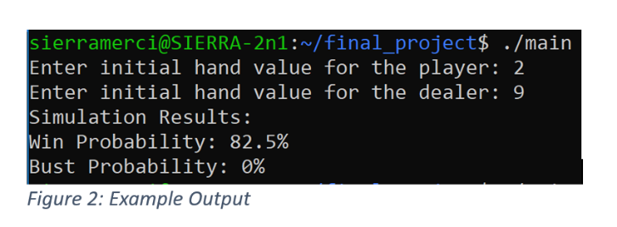**Output Examples**

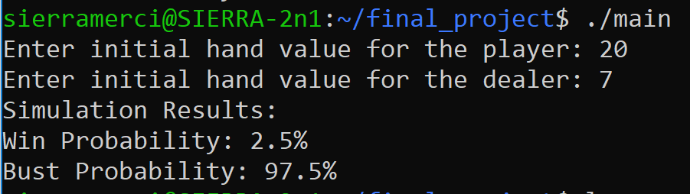

Figure : Example Output

**Future Enhancements**

Given more time and resources, several features could be integrated to elevate the Blackjack Odds Calculator to a more sophisticated tool. One key enhancement would involve the implementation of a more advanced user interface. Currently console-based, an upgraded interface might include graphical elements and improved interactivity, enhancing the overall user experience.

Furthermore, additional user prompts and validation mechanisms could be incorporated to ensure the program handles user inputs more robustly. For instance, the code could be extended to prompt users if they would like to "hit" again or "stand" after the initial hands are provided. This would involve integrating a loop that allows users to make multiple decisions, mirroring the dynamic nature of a real blackjack game.

Another valuable addition would be input value limits. Currently, the program assumes valid integer inputs for initial hand values. With more time, input validation checks could be implemented to ensure entered values fall within an acceptable range (e.g., between 2 and 21), preventing potential errors and providing a more user-friendly experience.

**Conclusion**

In conclusion, the Blackjack Odds Calculator provides an invaluable tool for blackjack enthusiasts seeking to enhance their gaming strategy. By offering insights into the probabilities associated with different scenarios, the program empowers players to make informed decisions during gameplay.